Experiment-01: Fuzzy Logic System
- Fuzzy Logic is a form of many-valued logic in which truth values of variables may be any real number between 0 and 1.
- Unlike traditional binary logic (Boolean logic), which sees the world in black and white (True/1 or False/0), fuzzy logic handles the concept of "partial truth."
- It mimics human reasoning, which relies on vague and approximate terms rather than precise mathematics.

Problem-01: Fan Speed Controller
Input | Output
temperature={  'cold':[20,50],  'warm':[40,75],  'hot':[65,100]  } | fan_speed={  'slow':[15,40],  'medium':[35,50],  'fast':[45,60]  }
#Rules:
- If the temperature is hot, the fan will move fast.
- If the temperature is warm, the fan will move medium.
- If the temperature is cold, the fan will move slow.
# Membership Graph:

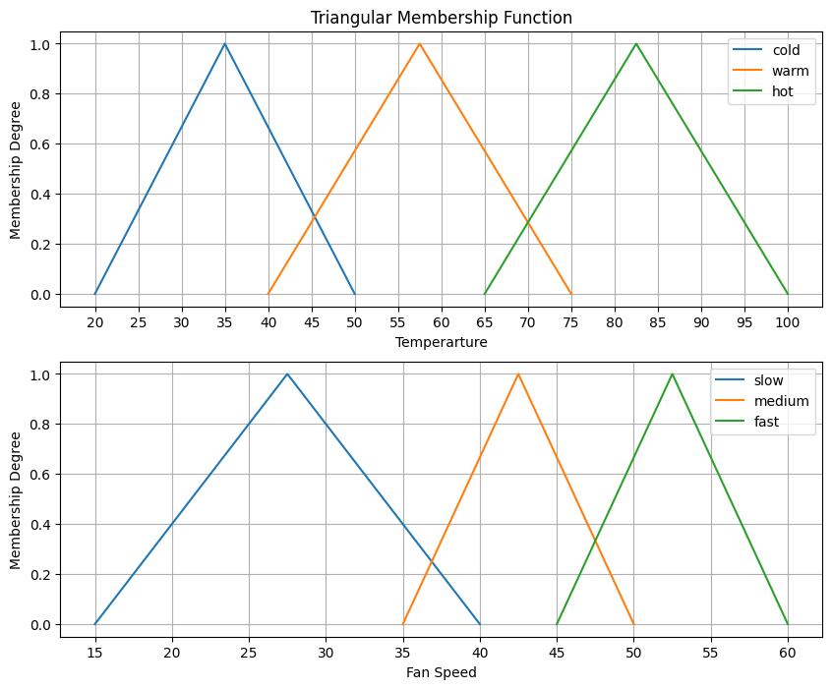

Source Code:
def rules(temp):
if(temp=='hot'):
return np.sum(fan_speed['fast'])/2
elif(temp=='warm'):
return np.sum(fan_speed['medium'])/2
elif(temp=='cold'):
return np.sum(fan_speed['slow'])/2

def membership_degree(x,s):
a=temperature[s][0] # minimum value
b=np.mean(temperature[s]) # mid value
c=temperature[s][1] #max value
if x>=c:
return 0
if x>b:
return (c-x)/(c-b)
if x>a:
return (x-a)/(b-a)
else:
return 0

def Fuzzy(x):
membership_value=[]
for i,j in temperature.items():
result=membership_degree(x,i) # take the membership value from given input
membership_value.append(result)
print(membership_value)

crisp_speed=[]
for i in temperature:
crisp_speed.append(rules(i)) # storing the rule
print(crisp_speed)

crisp_speed=np.array(crisp_speed)
try:
crisp_speed=crisp_speed*np.array(membership_value) #multiplication
crisp_speed=np.sum(crisp_speed)/np.sum(membership_value) # Divide
except:
crisp_speed=0
return crisp_speed

x=45
print(f"{Fuzzy(x):.3f}") #final result

Output:
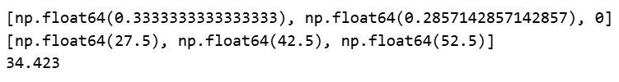

Problem-02: Soil’s Moisture Level Controller
Input | Output
Moisture={  'dry':[-40,40],  'moist':[30,70],  'wet':[60,140]  } | Irrigation={  'short':[-20,20],  'medium':[15,45],  'long':[40,80]  }
#Rules:
- If the soil is dry, the irrigation time will take long.
- If the soil is moisture, the irrigation time will take medium.
- If the soil is wet, the irrigation time will take short.
# Membership Graph:

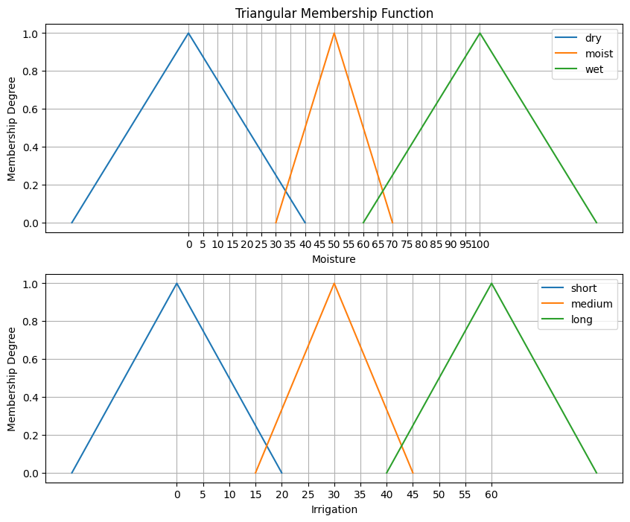

Source Code:
def rules(temp):
if(temp=='dry'):
return np.sum(Irrigation['long'])/2
elif(temp=='moist'):
return np.sum(Irrigation['medium'])/2
elif(temp=='wet'):
return np.sum(Irrigation['short'])/2

def membership_degree(x,s):
a=Moisture[s][0]
b=np.mean(Moisture[s])
c=Moisture[s][1]
if x>=c:
return 0
if x>b:
return (c-x)/(c-b)
if x>a:
return (x-a)/(b-a)
else:
return 0

def Fuzzy(x):
membership_value=[]
for i in Moisture:
result=membership_degree(x,i)
membership_value.append(result)
print(membership_value)

crisp_irrigation=[]
for i in Moisture:
crisp_irrigation.append(rules(i))
print(crisp_irrigation)

crisp_irrigation=np.array(crisp_irrigation)
try:
crisp_irrigation=crisp_irrigation*np.array(membership_value)
crisp_irrigation=np.sum(crisp_irrigation)/np.sum(membership_value)
except:
crisp_irrigation=0

return crisp_irrigation

x=39
print(f"{Fuzzy(x):.3f}") #final result
Output:
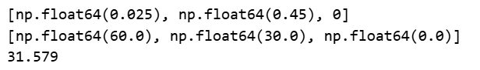

Problem-03: AC Temperature Controller
Input | Output
humidity={  'dry':[-40,40],  'optimal':[30,70],  'humid':[60,140]  } | temperature={  'cool':[10,22],  'normal':[20,26],  'eco':[24,36]  }
#Rules:
- If the Humidity is optimal, the temperature will set to normal range.
- If the Humidity is humid, the temperature will set to eco-friendly range.
- If the Humidity is dry, the temperature will set to cooling range.
# Membership Graph:

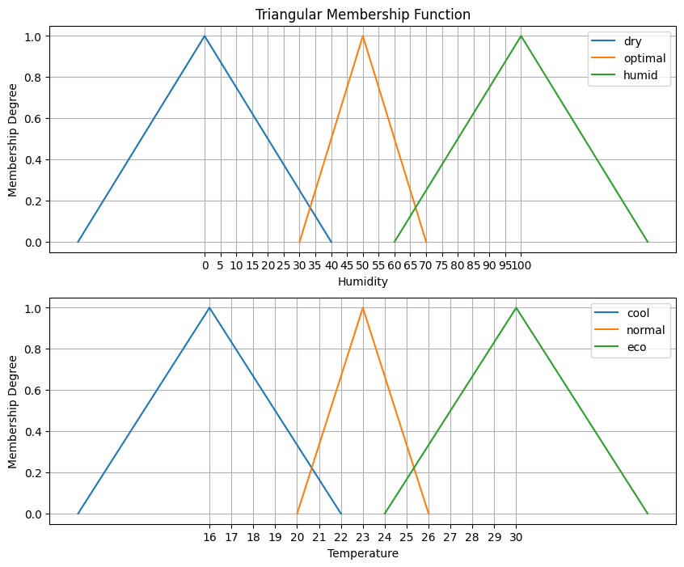

Source Code:
def rules(value):
if(value=='optimal'):
return np.sum(temperature['normal'])/2
elif(value=='humid'):
return np.sum(temperature['eco'])/2
elif(value=='dry'):
return np.sum(temperature['cool'])/2

def membership_degree(x,s):
a=humidity[s][0] # minimum value
b=np.sum(humidity[s])/2 # mid value
c=humidity[s][1] #max value
if x>=c:
return 0
if x>b:
return (c-x)/(c-b)
if x>a:
return (x-a)/(b-a)
else:
return 0

def Fuzzy(x):
membership_value=[]
for i,j in humidity.items():
result=membership_degree(x,i) # take the membership value from given input
membership_value.append(result)
print(membership_value)

crisp_temp=[]
for i in humidity:
crisp_temp.append(rules(i)) # storing the rule
print(crisp_temp)

crisp_temp=np.array(crisp_temp)
try:
crisp_temp=crisp_temp*np.array(membership_value) #multiplication
crisp_temp=np.sum(crisp_temp)/np.sum(membership_value) # Divide
except:
crisp_temp=0
return crisp_temp

x=35
print(f"{Fuzzy(x):.3f}") #final result
Output:
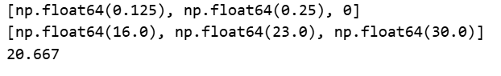

Problem-04: Daily Calorie Burn Rate Determination
Input | Output
bmi={  'lean':[15,22],  'healthy':[18,28],  'high':[24,35]  } | burn_rate={  'low':[0,14],  'medium':[7,17],  'high':[12,25]  }
#Rules:
- If the BMI is in healthy range, the Burn Rate is medium.
- If the BMI is in high range, the Burn Rate is high.
- If the BMI is in lean range, the Burn Rate is low.
# Membership Graph:

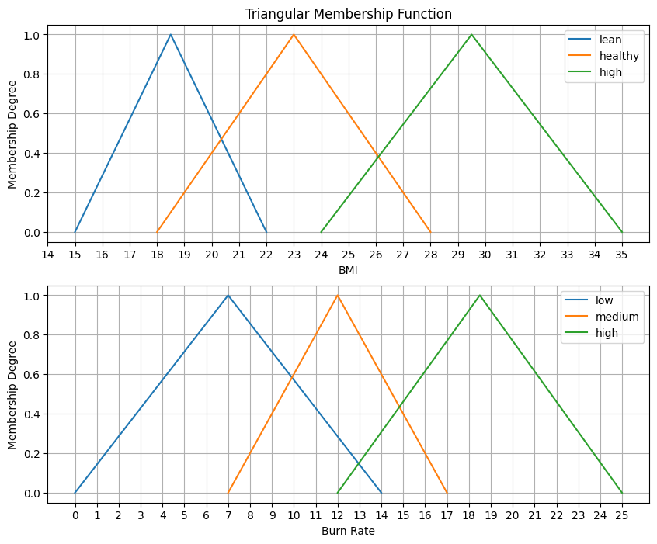

Source Code:
def rules(value):
if(value=='healthy'):
return np.sum(burn_rate['medium'])/2
elif(value=='high'):
return np.sum(burn_rate['high'])/2
elif(value=='lean'):
return np.sum(burn_rate['low'])/2

def membership_degree(x,s):
a=bmi[s][0] # minimum value
b=np.mean(bmi[s]) # mid value
c=bmi[s][1] #max value
if x>=c:
return 0
if x>b:
return (c-x)/(c-b)
if x>a:
return (x-a)/(b-a)
else:
return 0

def Fuzzy(x):
membership_value=[]
for i,j in bmi.items():
result=membership_degree(x,i) # take the membership value from given input
membership_value.append(result)
print(membership_value)

crisp_burn=[]
for i in bmi:
crisp_burn.append(rules(i)) # storing the rule
crisp_burn=np.array(crisp_burn)

try:
crisp_burn=crisp_burn*np.array(membership_value) #multiplication
crisp_burn=np.sum(crisp_burn)/np.sum(membership_value) # Divide
except:
crisp_burn=0

return crisp_burn

x=26
print(f"{Fuzzy(x):.3f}") #final result

Output:
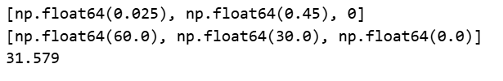

Conclusion:
In conclusion, Fuzzy Logic Systems provide a mathematical framework for modeling uncertainty and vagueness, allowing machines to make decisions based on ambiguous data like human intuition. By processing "degrees of truth" rather than binary absolutes, it enables the creation of control systems that are more robust, adaptable, and easier to implement for complex, non-linear problems. Key Applications are Consumer Electronics, Automotive Systems, Air Conditioning and Climate Control, Medical Diagnosis Systems, Pattern Recognition and Image Processing, Aerospace Control, Stock Market Prediction Systems

